EXPERIMENT – 1
QUESTION
Execute and display the results for the following commands in Kali Linux Operating Systems:
- rm command
- users command
- tree command
AIM
To execute and display the results of the rm, users, and tree commands in Kali Linux Operating System.
COMMANDS AND OUTPUT
1. rm Command
Command:
touch test.txt
ls
rm test.txt
ls
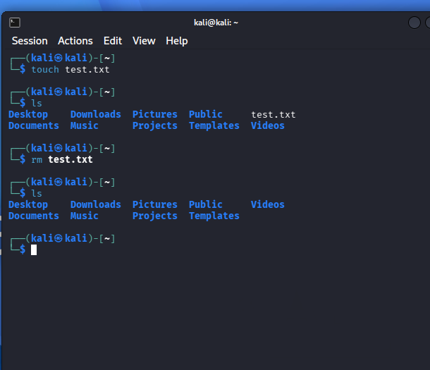

2. users Command
Command:
Users
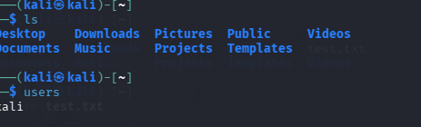
3. tree Command
Command:
tree
Output:
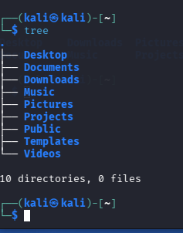
FINAL RESULT
Thus, the rm, users, and tree commands were successfully executed and their results were displayed in Kali Linux.

